**Lesson 01 HTTP's Request/Response Cycle**

**Http Request:** Is actually a common way to retrieve hyper text documents, which can have dynamic references (links) to other documents.

Client and servers are connected with request.

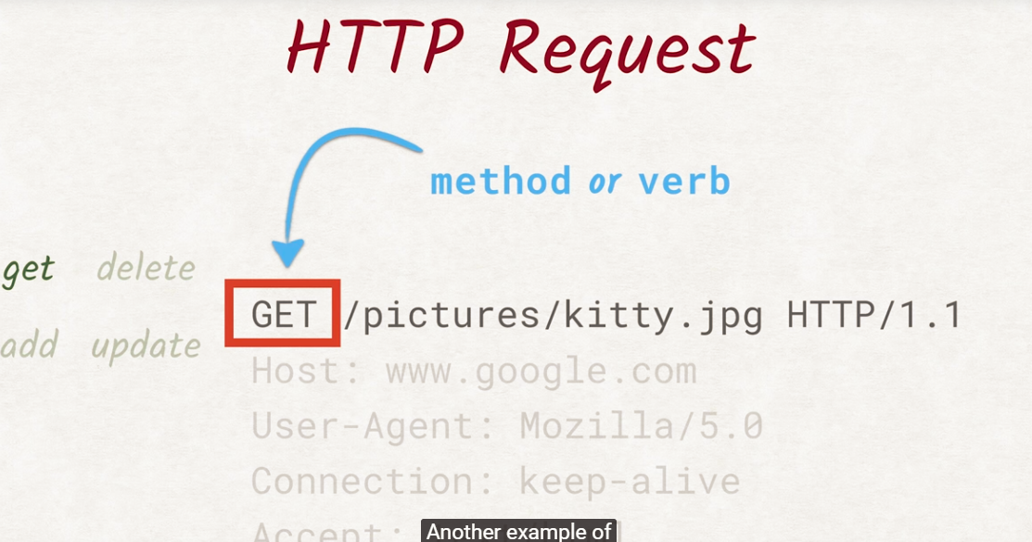

1. The procotoll determines wether a text is to be retrieved, deleted, updated by defining what we want.

**Request Header:** Additional data regarding the request

* **Host** header is necessary

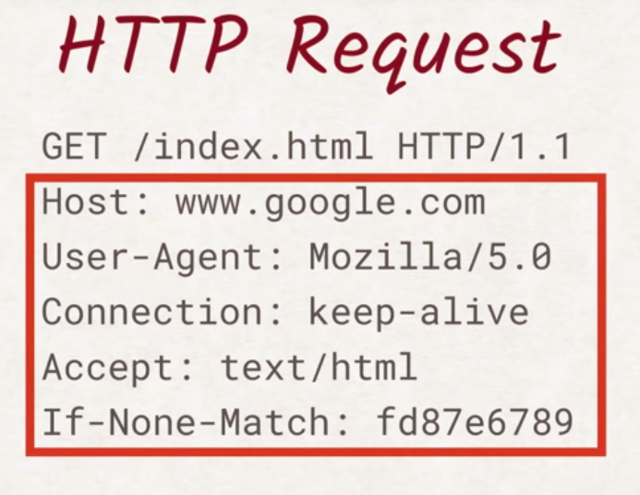

**HTTP Response**

* **Content-length**: is necessary + the **<binary>** data recieved

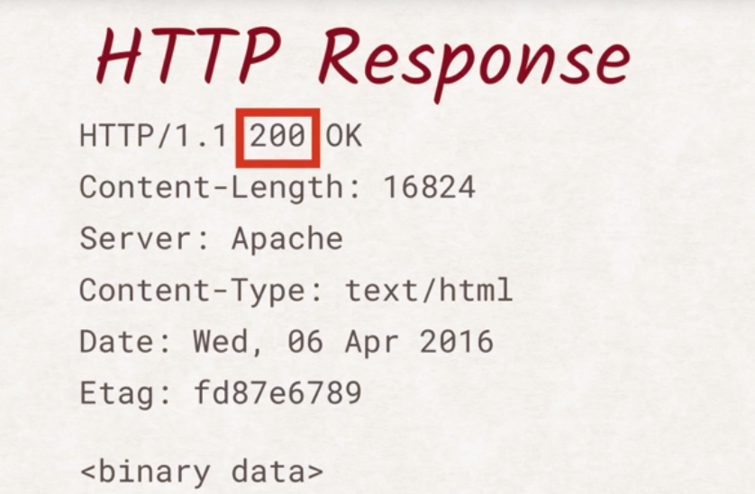

**Lesson 02 HTTP/1**

**Http verbs:**  Are the methods to tell the server in the http request what to do with the recieved info

1. Only adding the **HEAD** we can check if we have enough space to store the response

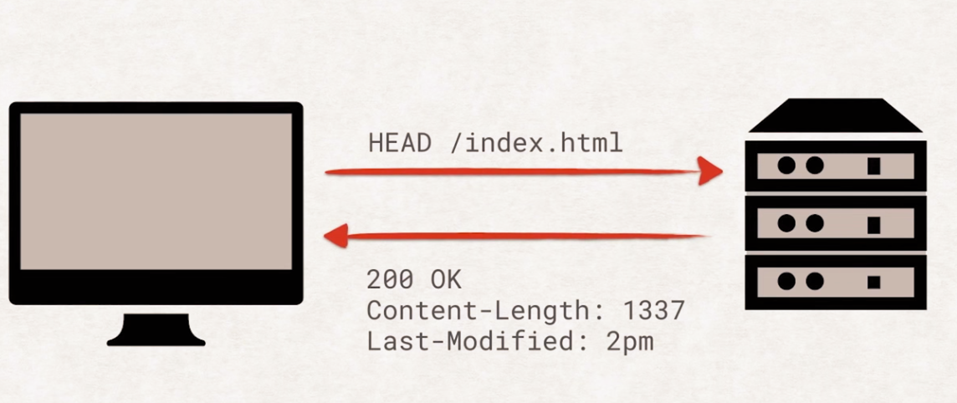

It is important to know, that these **roundtrips** are expensive

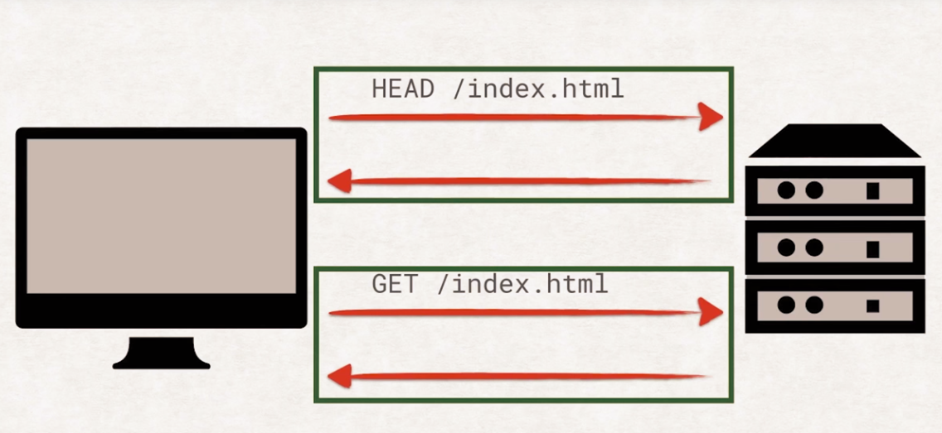

Response headers:

**Response Headers**

Headers contain additional data about requests or responses. These are some of the important ones:

Content-Length is a header that must be contained in every response and tells the browser the size of the body in the response. This way the browser knows how many bytes it can expect to receive after the header section and can show you a meaningful progress bar when downloading a file.

Content-Type is also a non-optional header and tells you what type the document has. This way the browser knows which parsing engine to spin up. If it's an image/jpeg, show the image. It’s text/html? Let’s parse it and fire off the necessary, additional HTTP requests. And so on.

Last-Modified is a header that contains the date when the document was last changed. It turned out that the Last-Modified date is not very reliable when trying to figure out if a document has been changed. Sometimes developers will uploaded all files to the server after fixing something, resetting the Last-Modified date on all files even though the contents only changed on a subset. To accommodate this, most servers also send out an ETag. ETag stands for entity tag, and is a unique identifier that changes solely depending on the content of the file. Most servers actually use a hash function like SHA256 to calculate the ETag.

Cache-Control is exactly what it sounds like. It allows the server to control how and for how long the client will cache the response it received. Cache-Control is a complex beast and has a lot of built-in features. 99% of the time, you only need the “cacheability“ and the “max-age”.

If-Modified-Since permits the server to skip sending the actual content of the document if it hasn’t been changed since the date provided in that header. Is there something similar for ETags? Yes there is! The header is called If-None-Match and does exactly that. If the ETag for the document is still matching the ETag sent in the If-None-Match header, the server won’t send the actual document. Both If-None-Match and If-Modified-Since can be present in the same request, but the ETag takes precedence over the If-Modified-Since, as it is considered more accurate.

There are a lot more headers and a lot to explore. If you want to know more, check out the following information on HTTP headers:

**Web performances**

<https://www.youtube.com/watch?time_continue=94&v=ih5eRgfpDgU>

**Head-of-line blocking:** Is that the request are waiting, to be executed. The browser can open up 6 pararrel connections.

**Keep Alive:**

If you set in the header to have **connection: „keep-alive”**  the server will keep the connection alive, and you can make requests continously.

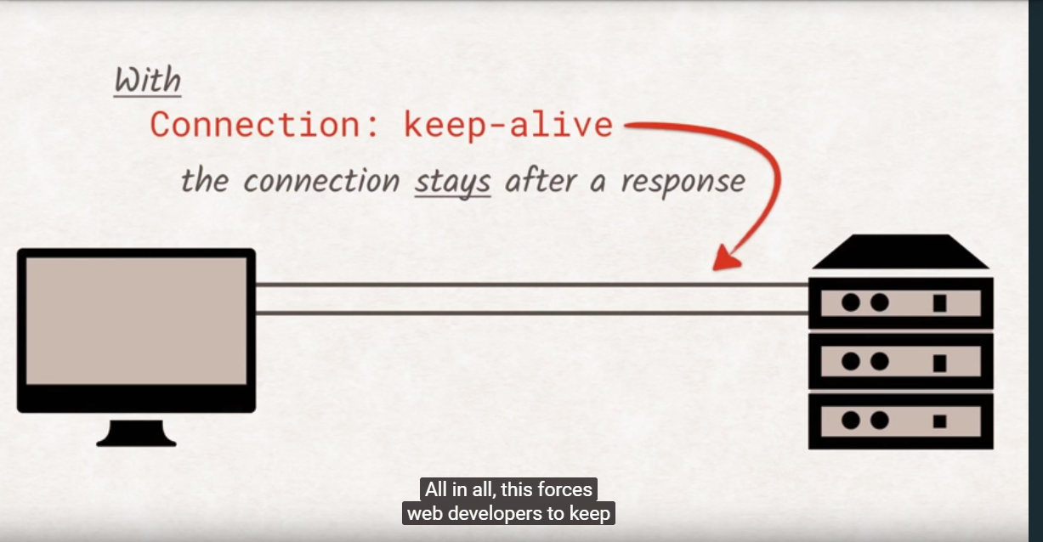

**Lesson 3 HTTPS**

Secure your request, connection

**Transport Layer Security:**

**Encryption** : needs the key for decrypting.

Text decrypted by one can be only read by the other key.

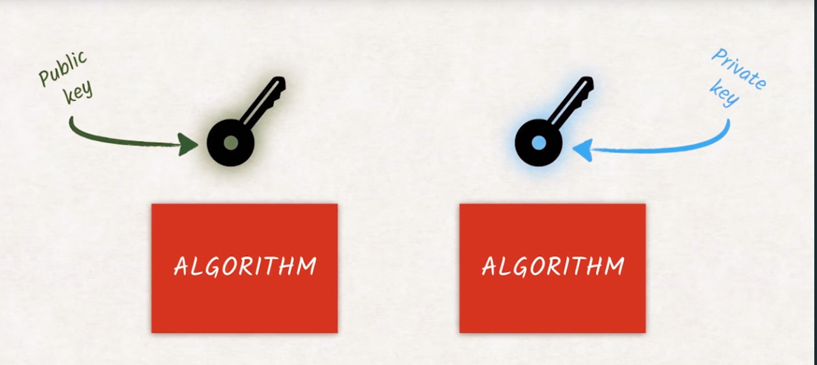

**Hashing** is to code text into a unique sequence of strings, and it can’T be reversed.

1. Have the certification, which has all of the information

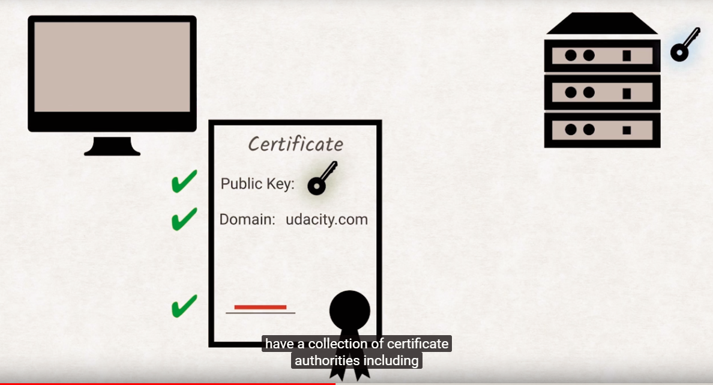

1. The client can check the public key, validate it and create a private random key

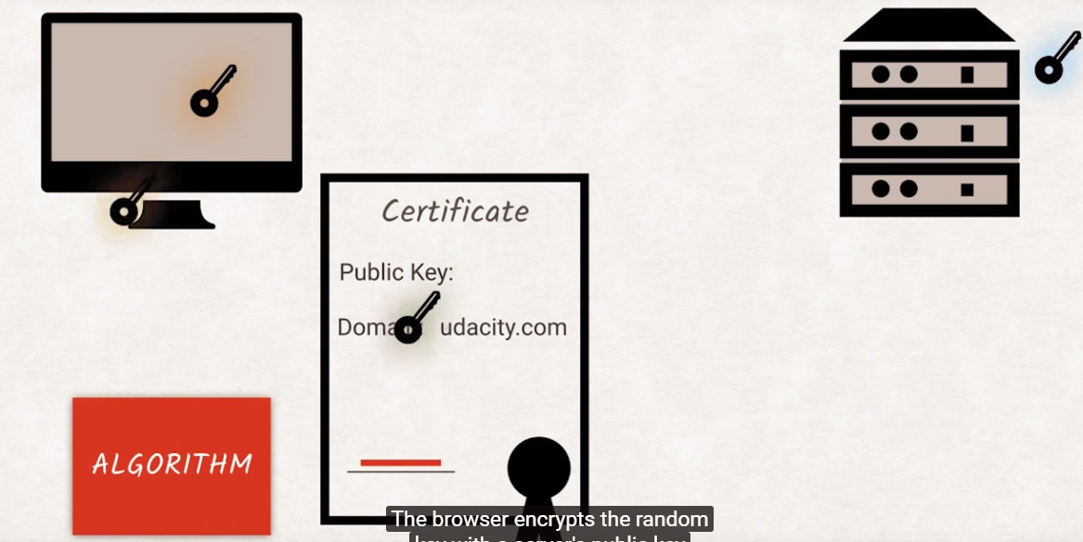

1. Which will be decrypted by the server, so if the server can understand the newly generated key, it shows that this is the true server

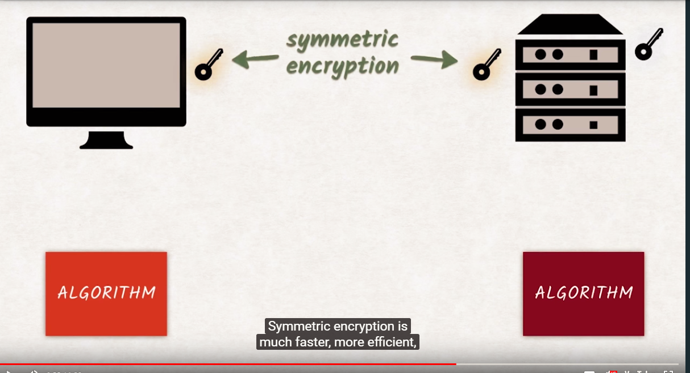

**HTTP2**

* Can handle compressed headers
* Can handle gzipped documents
* Works only with TLS

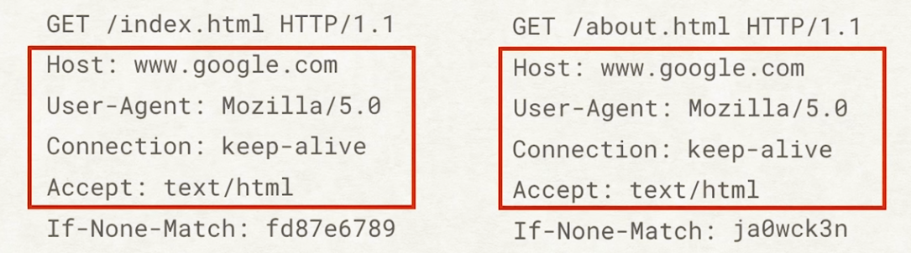

* Instead of creating simple 1 connection for each request, we make a stream connection where all of the data can be recieved continously without headofLine blocking + headers are compressed and not sent over multiple times
* 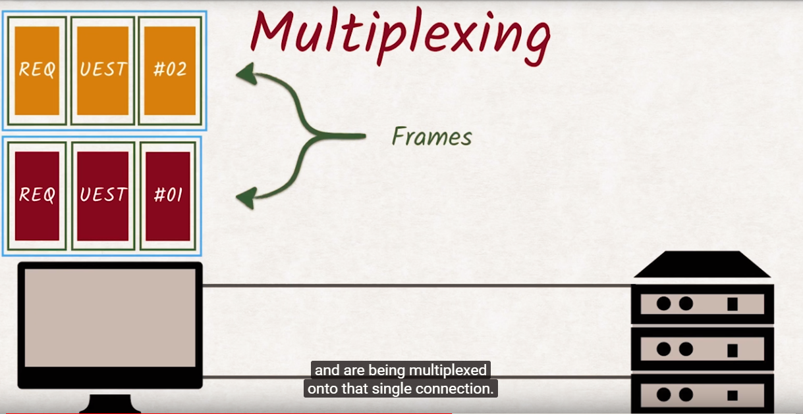

**Security**

1. **Same Origin Policy**

Origin is determined by the following 3 data

* Port(443)
* Hostname (udacity.com)
* Modelschema (HTTPS/HTTP)

Servers, browsers can’t make request to other server if they are not the same origins.

**The clients** are not allowing the requests to be made.

1. **Cross Origin Resource Sharing (CORS)**

**JSONP**

It is basically we are wrapping the request in a script tag, and adding a local function to be called.

So in this case, we get the courses and once it is done we are executing **f**  functions with the recieved data

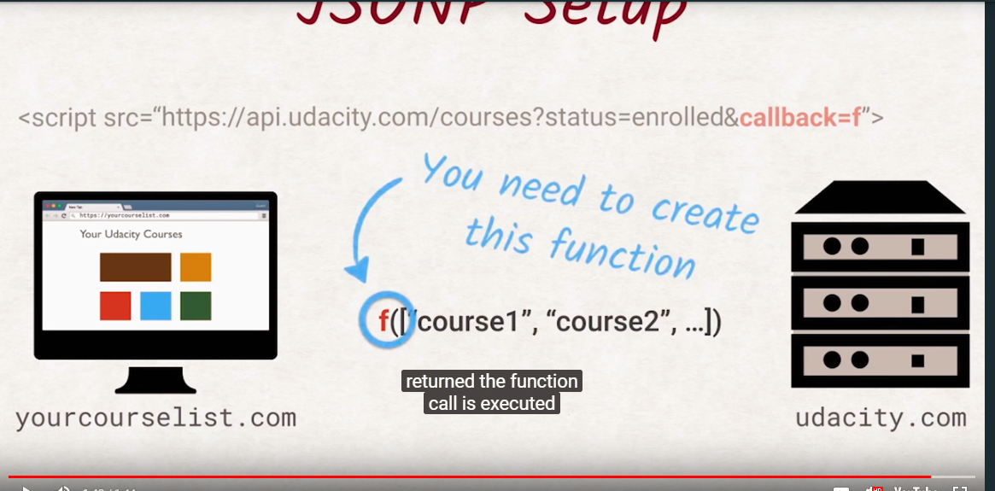

**Acess-control-allow-origin:**

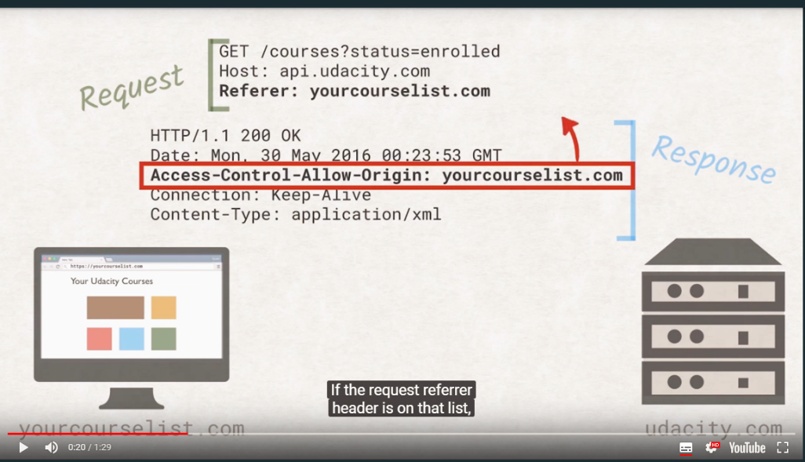The server will lett he allowed origins to access data, but it will tell immediately if you can access it or not. (images,fonts.etc)

For some scripts, **preflight requests** are sent, so you can check if you can fetch the data or not

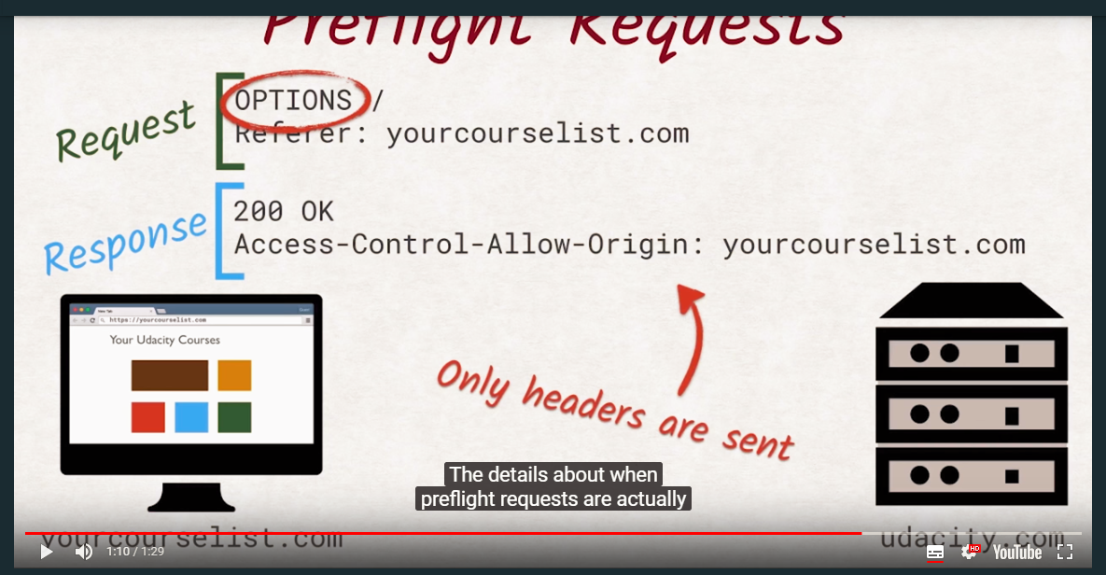

**Cross Site Request Forgers – CSRF**

* **CSRF Token**  is enough protection, it will just simply the server will send a token to the client side and it will only execute the code if the correct token has been recieved which is stored at the serverside as well.

**Cross Site Scripting**

* **XSS**  you can include scrip tags in the form and perform and js code in the client’s enviroment.
* **Validate** everything at server side!!

**Critical Rendering Path**

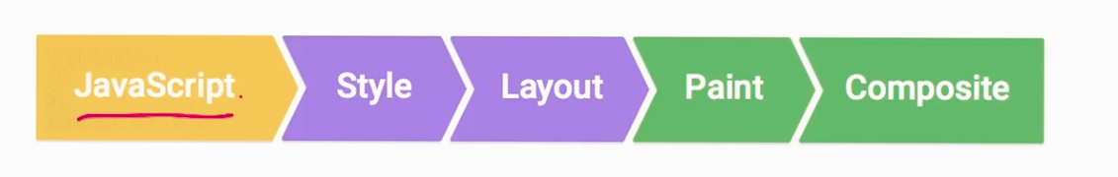

**Rail**

**R**esponse **A**nimation **I**dle **L**oad

**Load:**

Have it done as fast as possible

**Idle time:**

When we are waiting for user actions

Time what we have for events

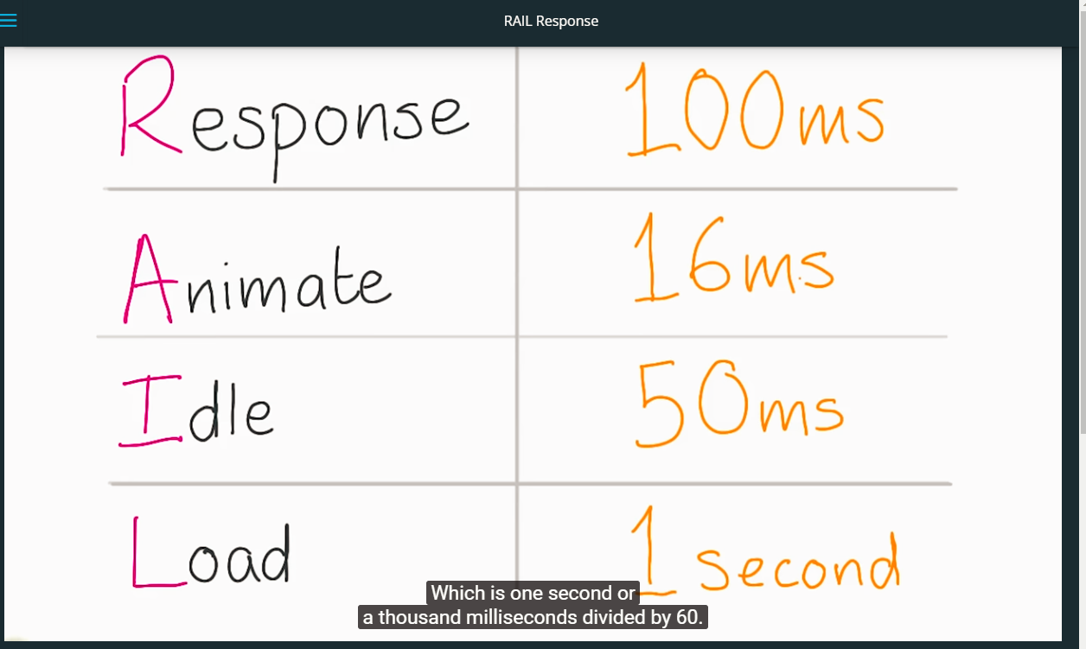

**Javascript Performance**

**Just In Time compiler:**

Javascript is compiled to a different set of code run by V8 engine. This is what we call JIT

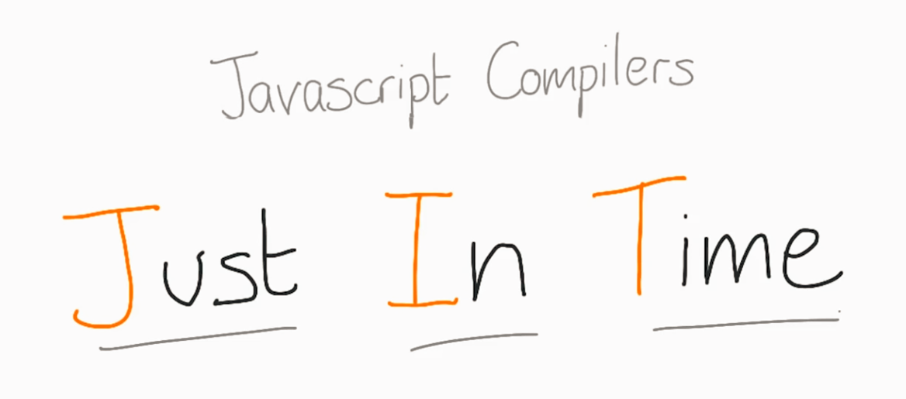

Request Animation Frame:

Will execute the js code and all of the stlye,layout,paint as soon as possbile but taking into consideration the pipeline.

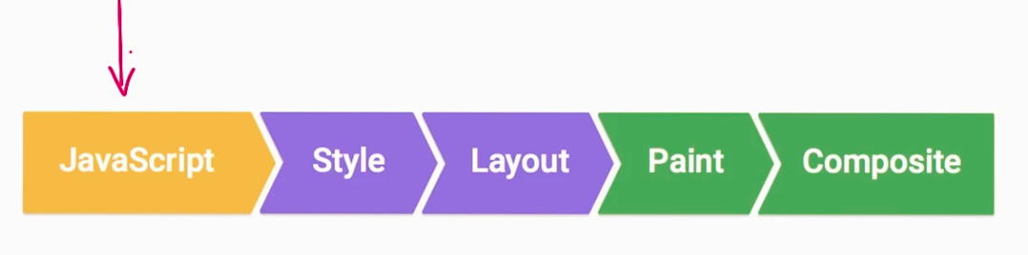

This is how we can use this built in function

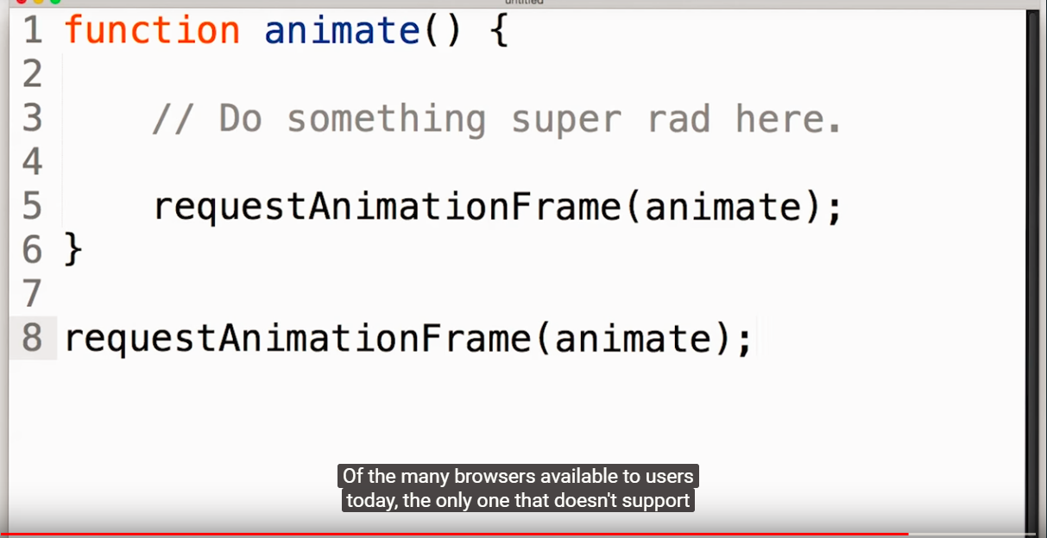

**Find long running js codes**

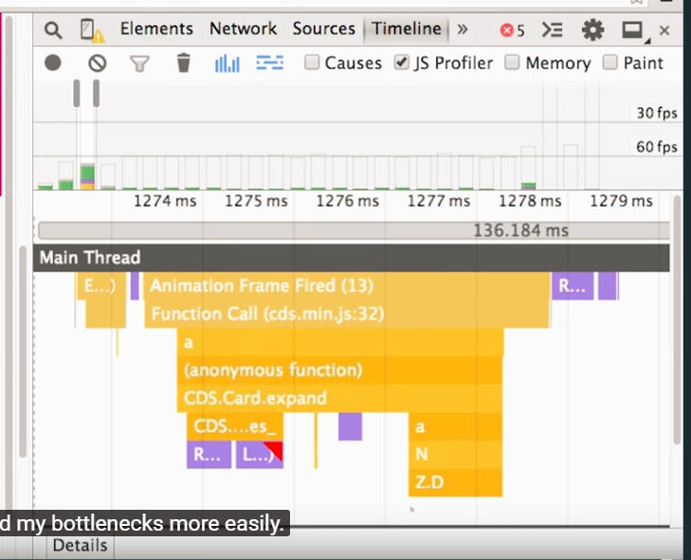

**Using Web Workers**

[**https://www.html5rocks.com/en/tutorials/workers/basics/**](https://www.html5rocks.com/en/tutorials/workers/basics/)

There are possbilities to outsorce some activities to the web workers, to a seperate thread and make the timeconsuming javascript tor un there.

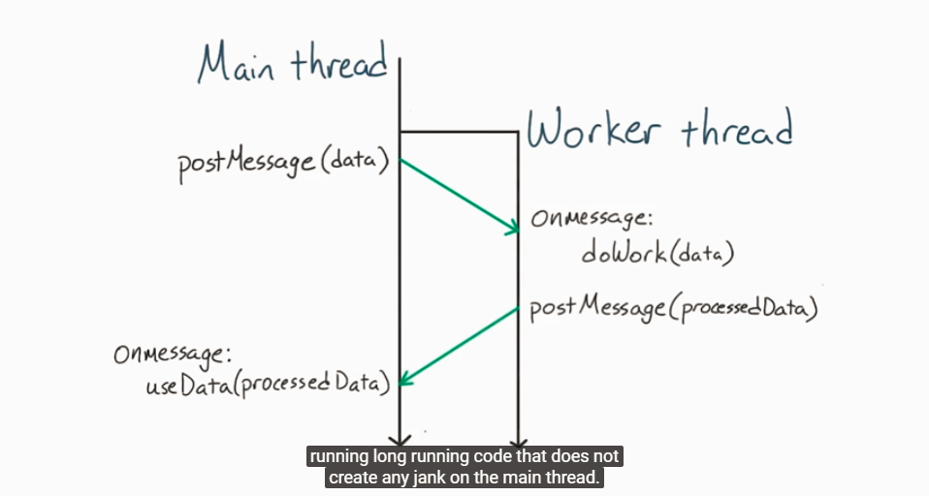

**Js Memory Management**

<https://www.smashingmagazine.com/2012/11/writing-fast-memory-efficient-javascript/>

<http://buildnewgames.com/garbage-collector-friendly-code/>

<https://developer.mozilla.org/en-US/docs/Web/JavaScript/Memory_Management>

It is garbage collected automatically, but when it runs, it stops all of the other code.

(You can see that it is using some memory and when it drops, the garbage is collected.)

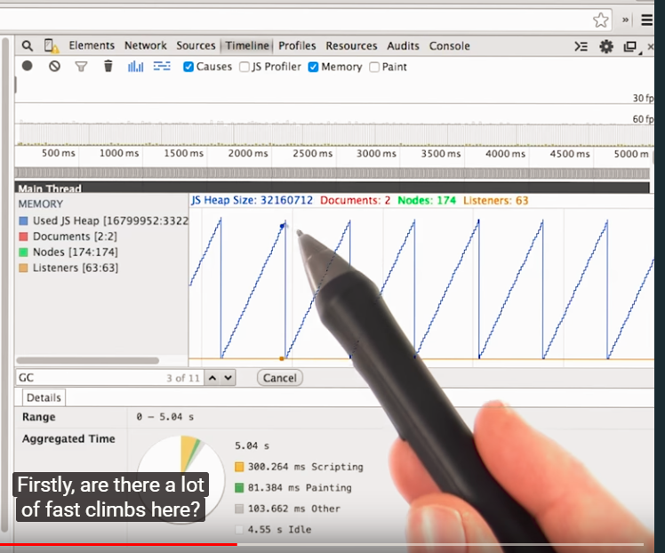

**Styles**

Use always, classes since it is a lot more faster to process by the css engine.

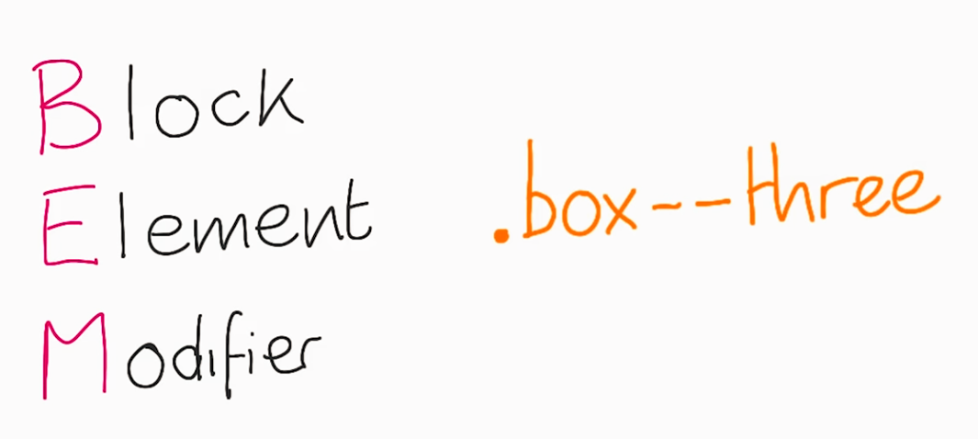

**Layout trashing (FSL – Forced Syncronous Layou)**

[**https://www.youtube.com/watch?time_continue=68&v=a9wbrTbg_RI**](https://www.youtube.com/watch?time_continue=68&v=a9wbrTbg_RI)

So, in the below code whenever we are trying to change a box’s width, we calculate the „**layout”**  of the box,. This is the 3rd step, but since then we jump back to js and set the style of the element, we loose time and efficiency.

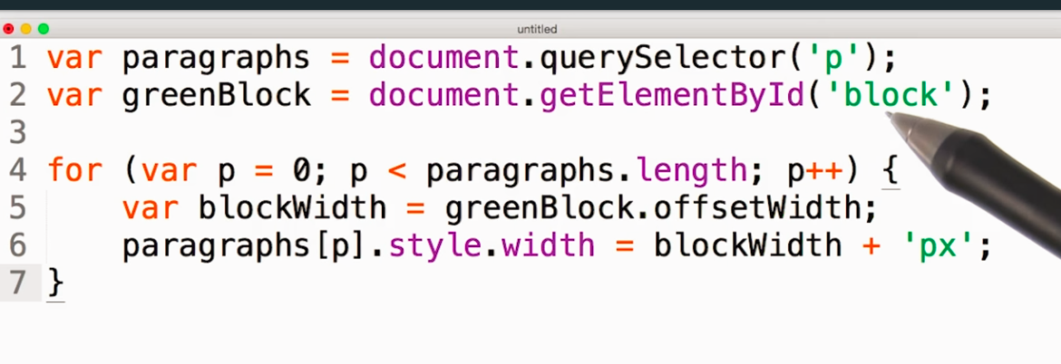

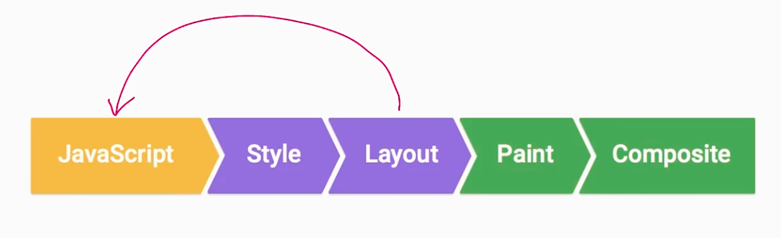

Chrome devtools will show it to you.

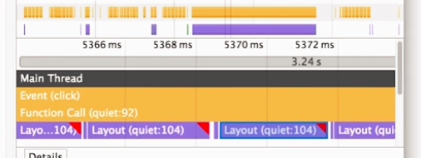

**Bad example for performance – FSL**

Here we are calculating the layout every time and then modify the stlye.

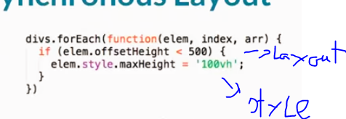

**These are the properties, methods which can trigger layout changes**

[**http://gent.ilcore.com/2011/03/how-not-to-trigger-layout-in-webkit.html**](http://gent.ilcore.com/2011/03/how-not-to-trigger-layout-in-webkit.html)

**Painting**

This will let you know, which js, or elements are cusing the browser to repaint the webpage.

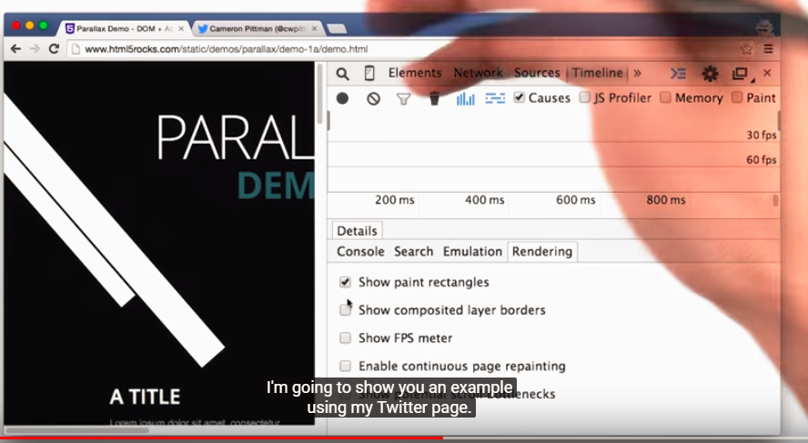

If you minimize the number of layers what you are using, than it would make your page faster sincet he page has to calculate less during the composition.